CSCI301 Assignment 3 Report

Done by: Colemann Gee Wei Shaun

7311369

Python version used

* 3.6.9

Requirements to run the code:

* Python 3.5 or above
* Pubnub pakages installed

An example directory for seamless execution:

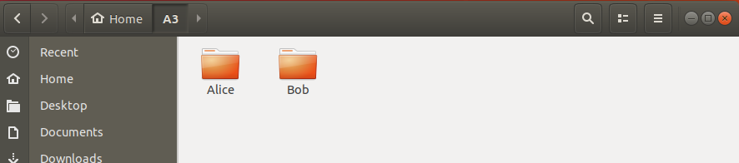

Inside the A3 folder

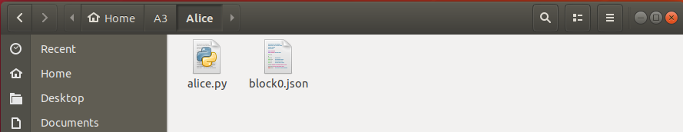Inside Alice folder

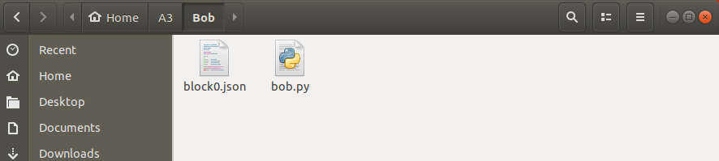Inside Bob folder

As the assignment specifies for Alice to take her turn first, bob.py will be run first to begin listening for messages sent by Alice.

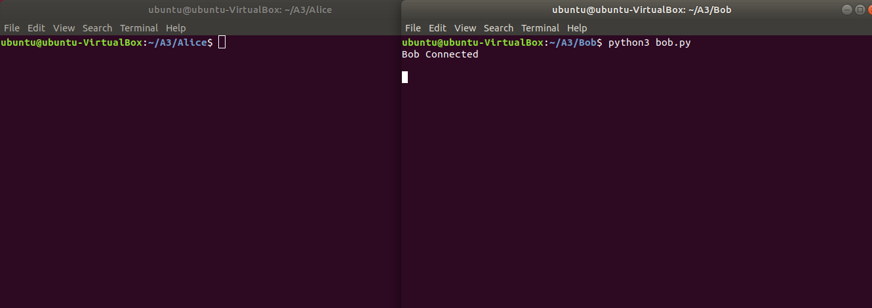

After Bob has connected, run alice.py.

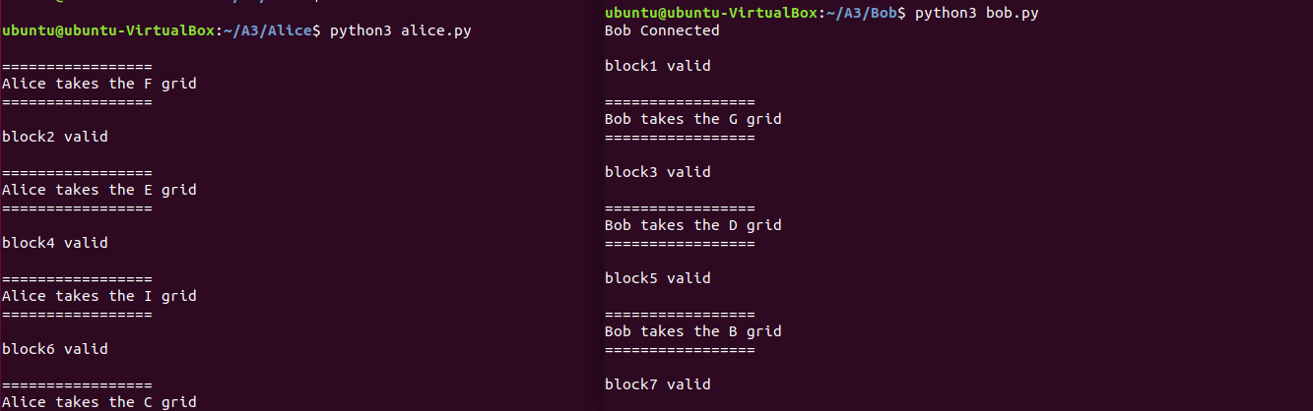

Alice will proceed to take the first turn and sending her created block information to Bob.

Bob proceeds to validate the received block and taking a turn of his own, sending the created block information back to Alice where the process repeats, until all 9 grid spaces have been taken up.

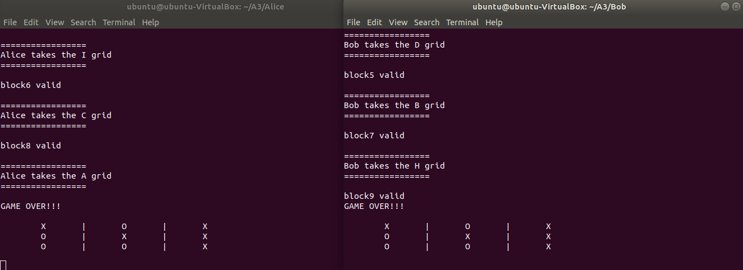

GAME OVER

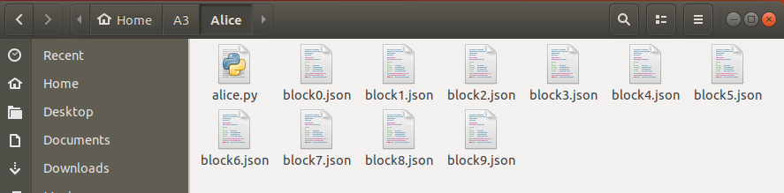

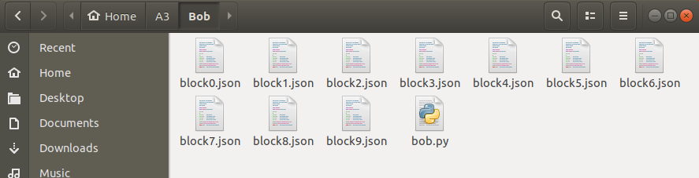

Block information are saved in both Alice and Bob’s folders.

Block Contents

block0.json is the genesis block whose contents have been specified by the assignment.

